**Lab Assignment 4**

**Team : 5**

Kiran Rao Boinapally – class ID : 3

Sai Srinivas Vidiyala – class ID : 29

**Video Link :**

<https://drive.google.com/open?id=1MI0yeYbGRw1ydOtCMv1_wkmA2Yzt6Fd7>

**Introduction** :

In this application, we are using the hardware feature camera to capture the pictures and upload in the firebase storage. In this we are fetching the Instagram profile pic of the specified user name.

**Method of flow:**

Initially when the user clicks on the buttons, using the intent activity it switches to different activities

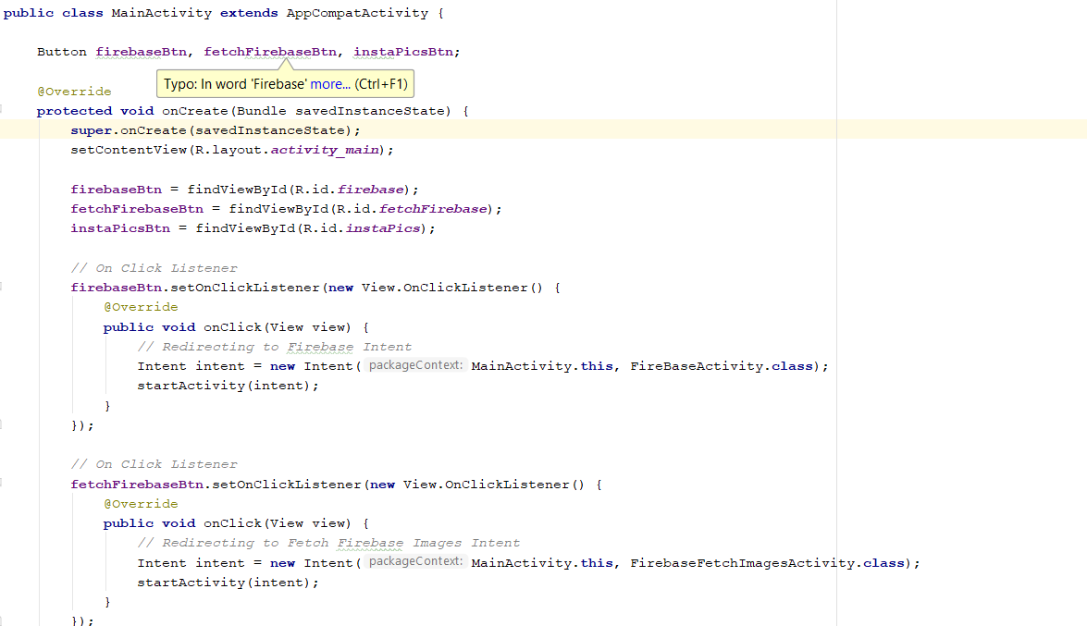

This is the UI of our application where we are uploading the images and fetching the image from the firebase storage and fetching the profile pic of the user from the Instagram.

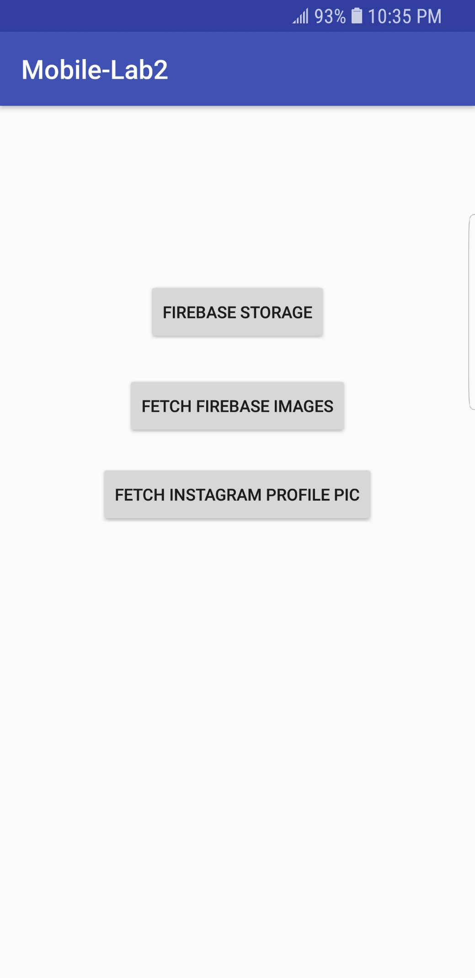

Initially a project is created in firebase developer.

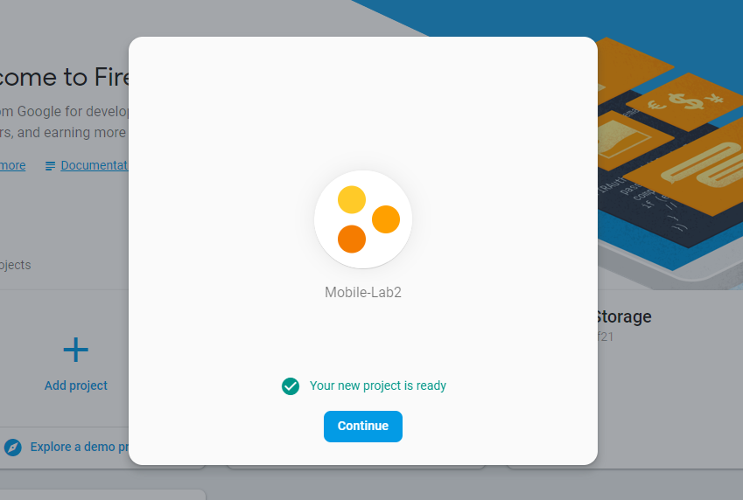

We are changing the few permissions like read and write to ‘true’ from false in the rules.

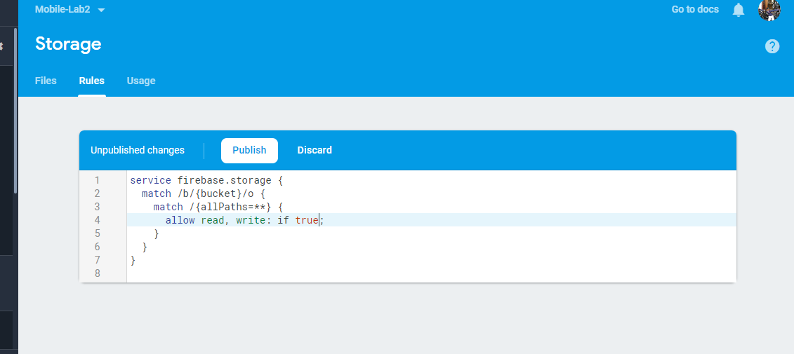

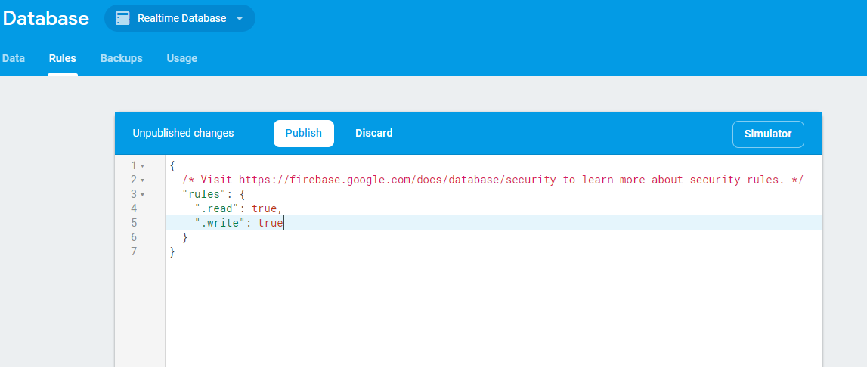

There are two buttons in fire base activity

One is to choose the picture from the gallery and the other button is to capture the picture using the camera application.

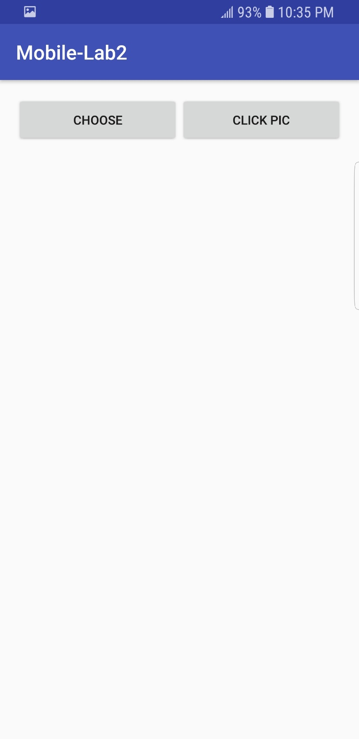

In order to choose the picture from the gallery, using the ACTION_GET_CONTENT we are selecting pictures and uploading in database.

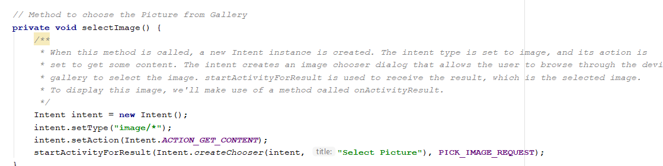

In order to upload the picture in firebase , using the byteData of the picture we upload it in the firebase

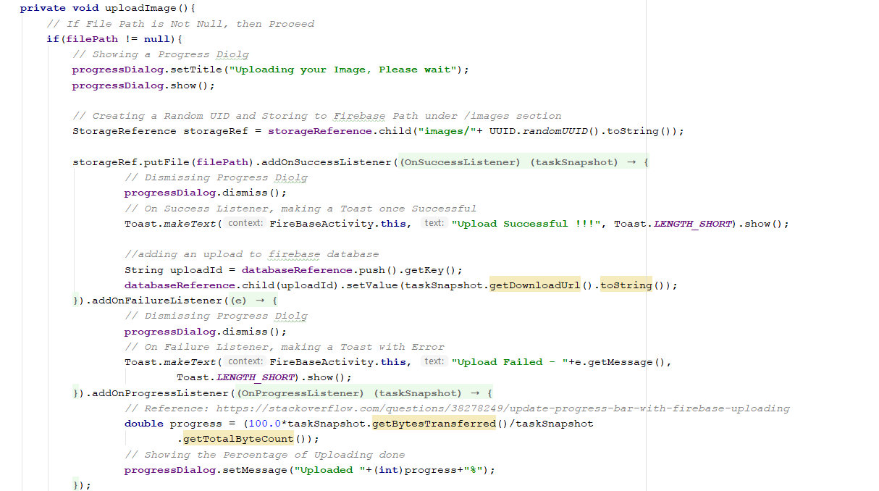

We can select the image from our local storage and upload it in to the firebase.

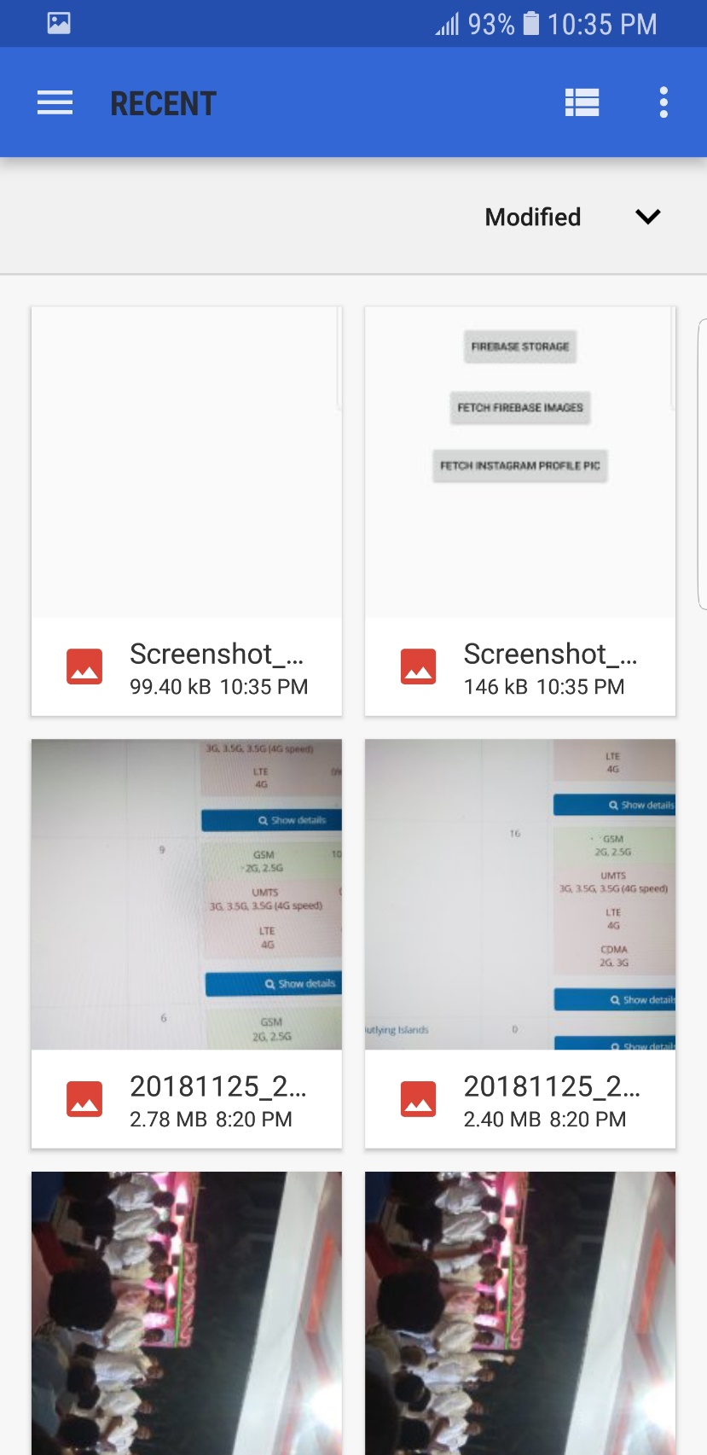

We can also capture the picture using the camera application. Here it is asking for permissions to choose one of the camera application.

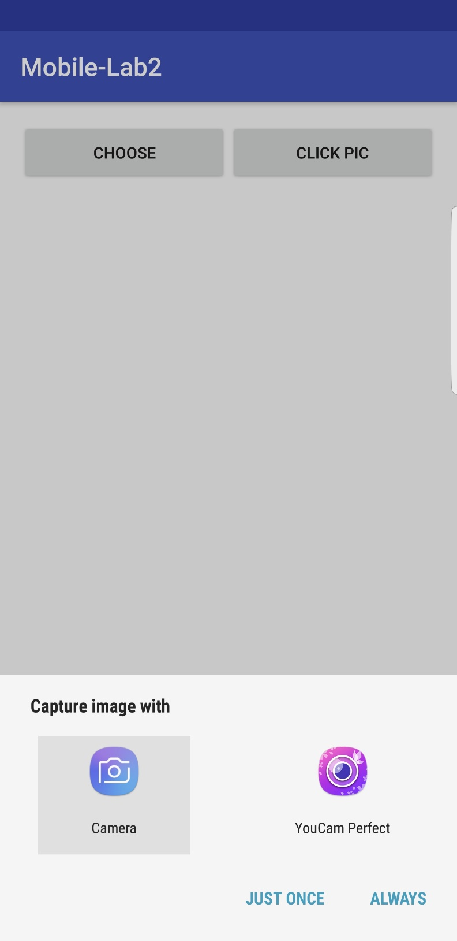

Following screenshots shows the photo uploading process and the image upload successful notification.

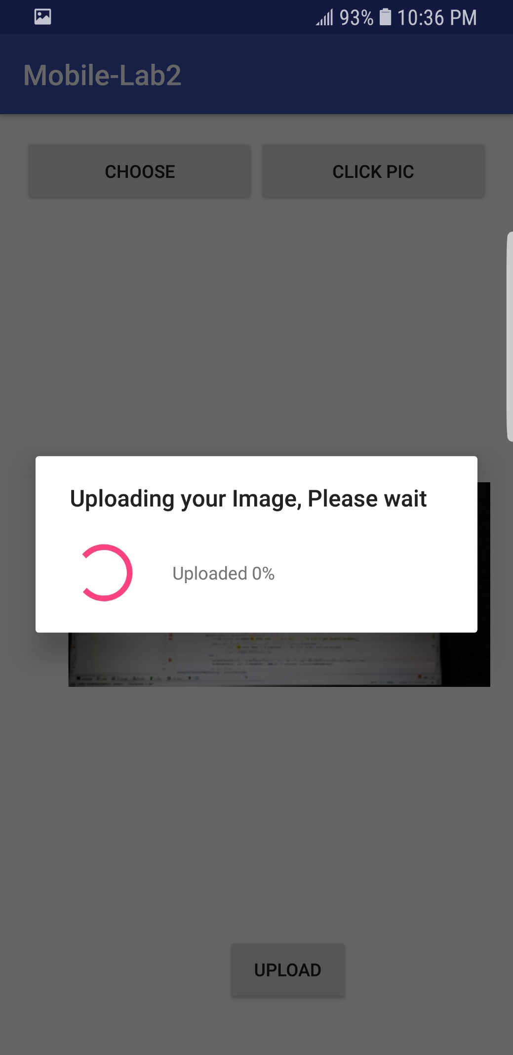

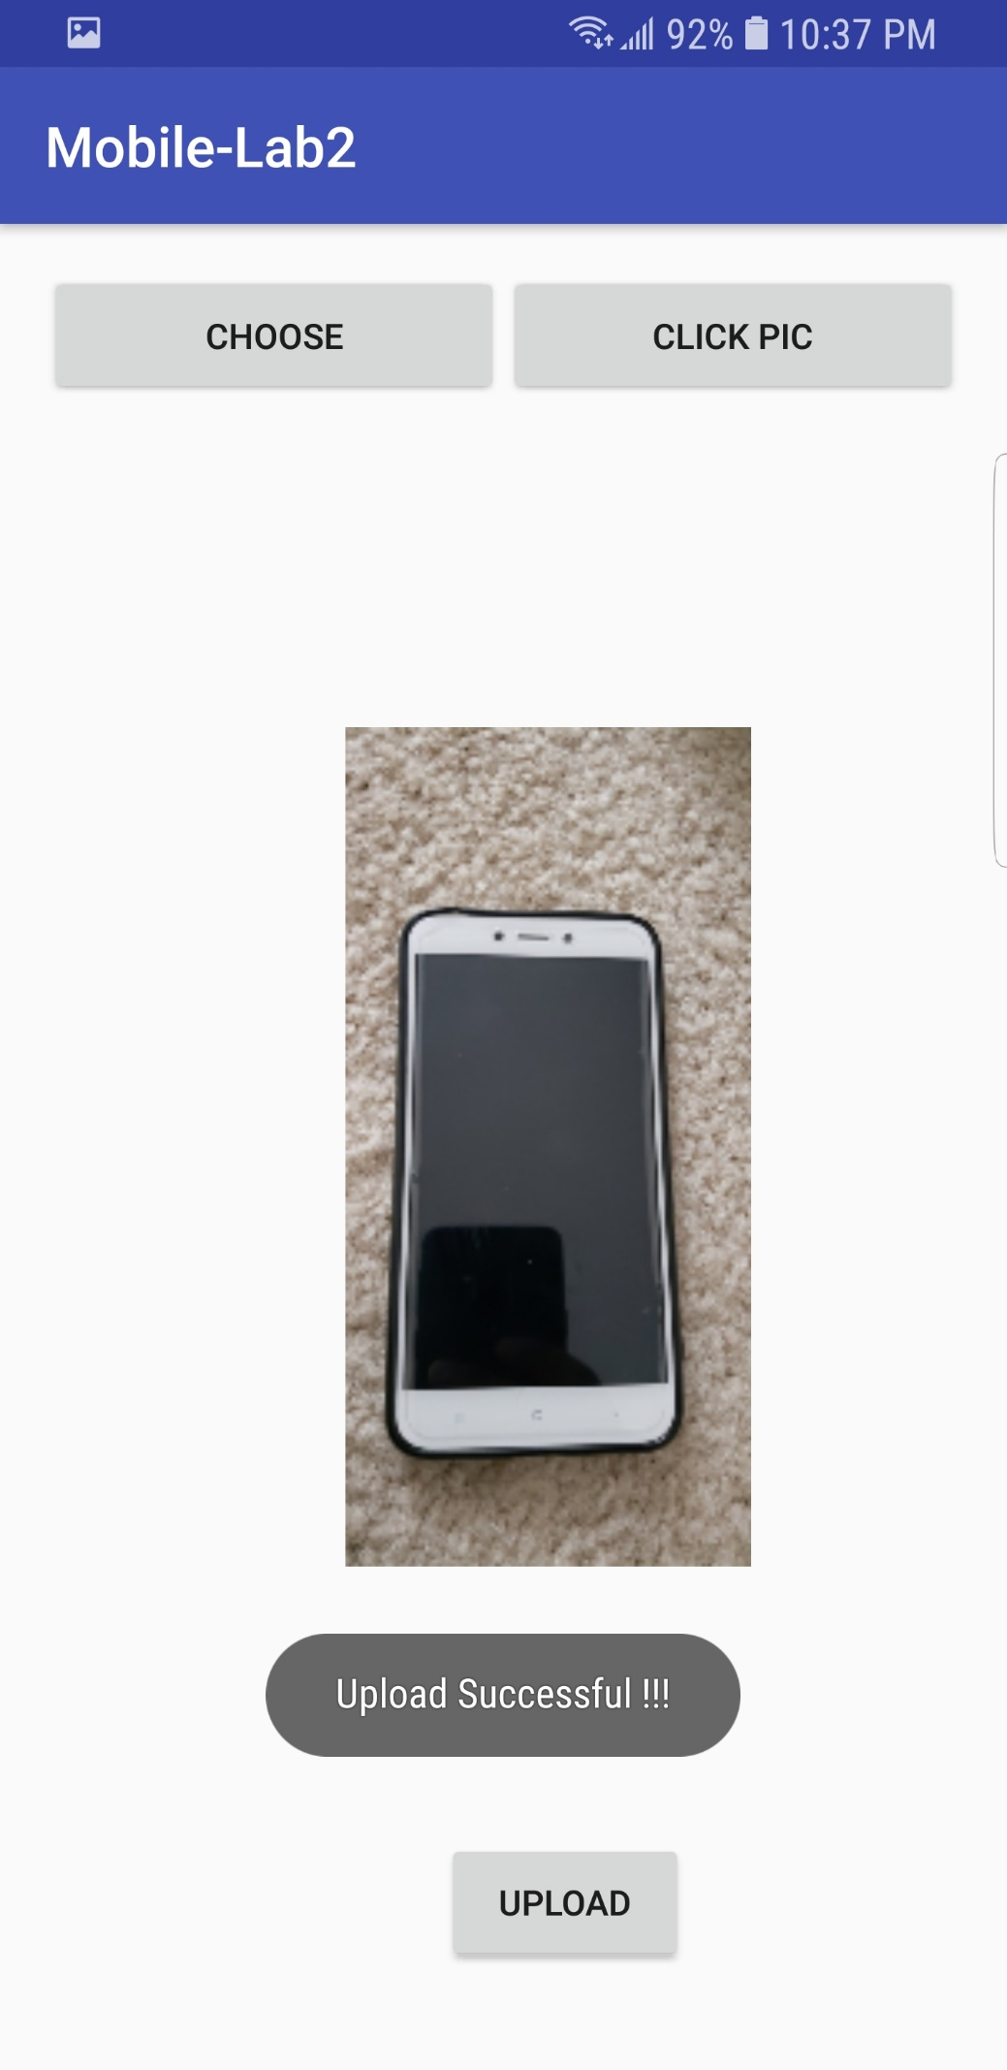

Data storage process in the firebase is done in the following manner.

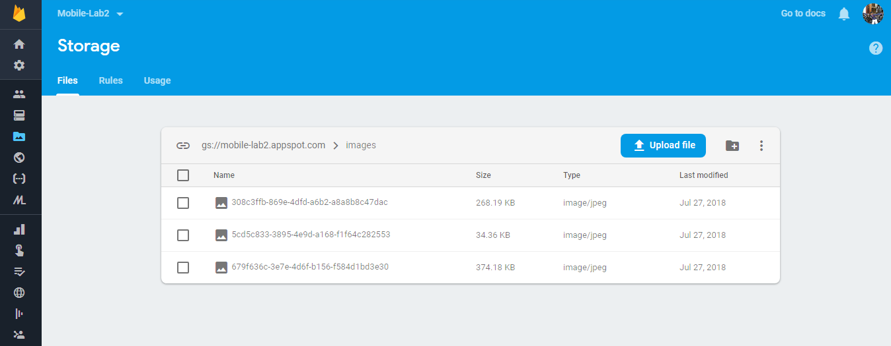

For each of the file stored in the database, it generates a url in the following manner.

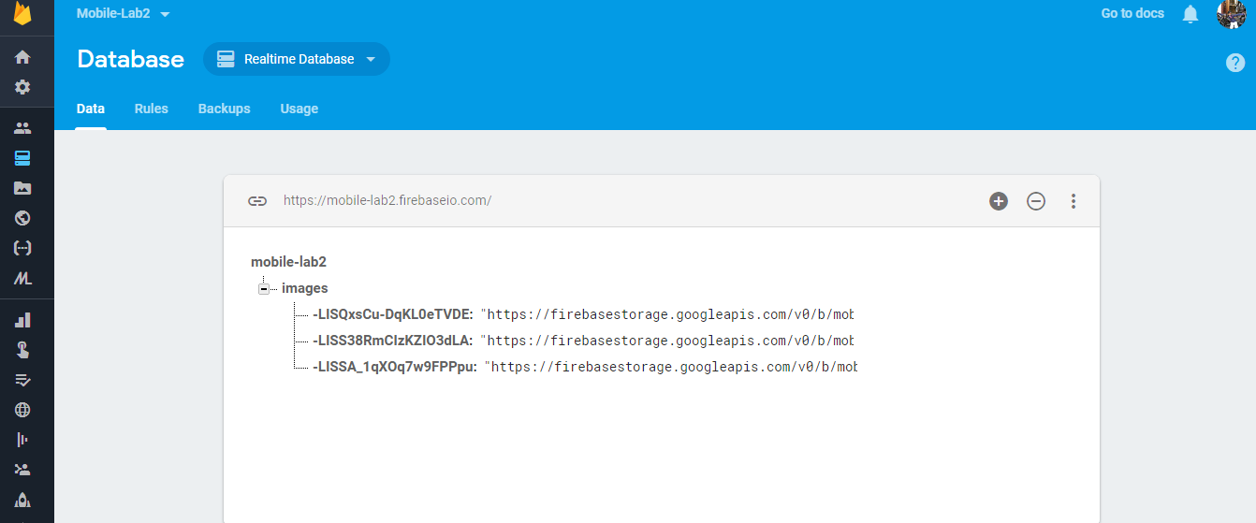

By converting the image to bitmap, we are displaying the images from the firebase.



We are giving different layout width and height to display all the images from the firebase in the grid format.

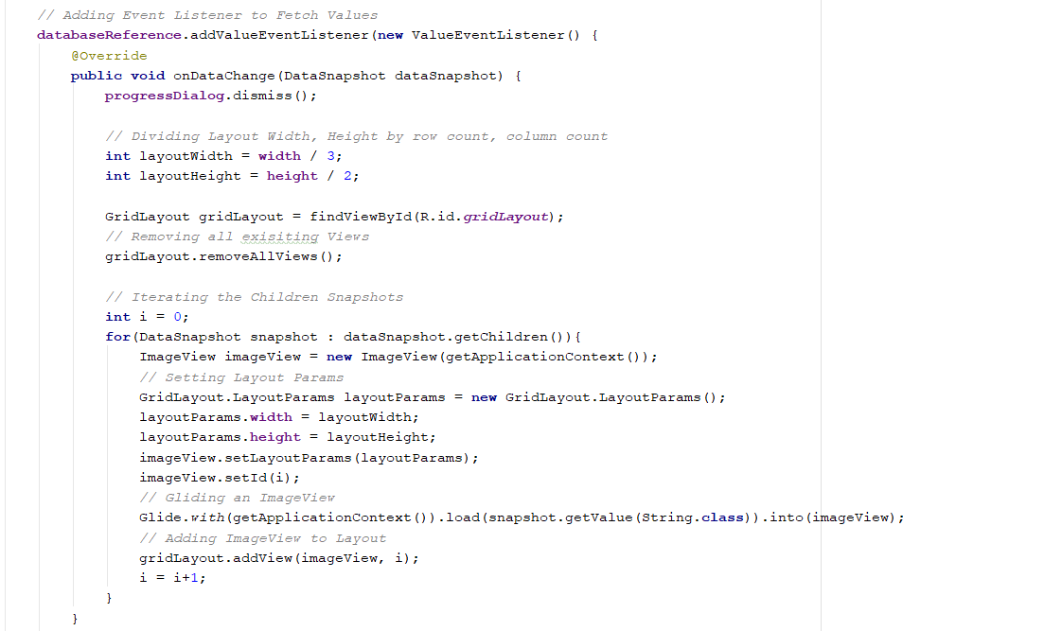

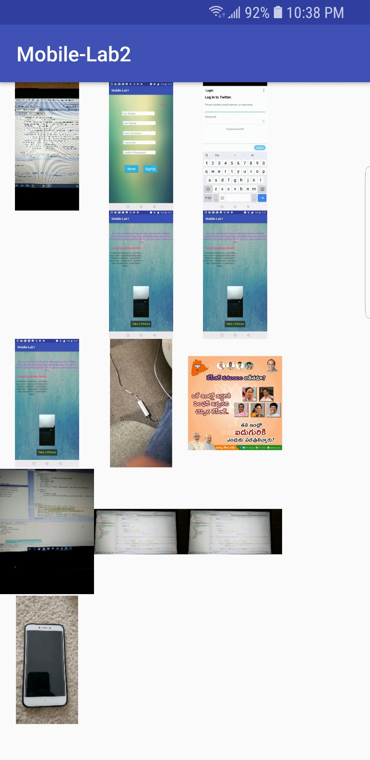

We are fetching the profile pic of the Instagram user using the following API mentioned in the picture.

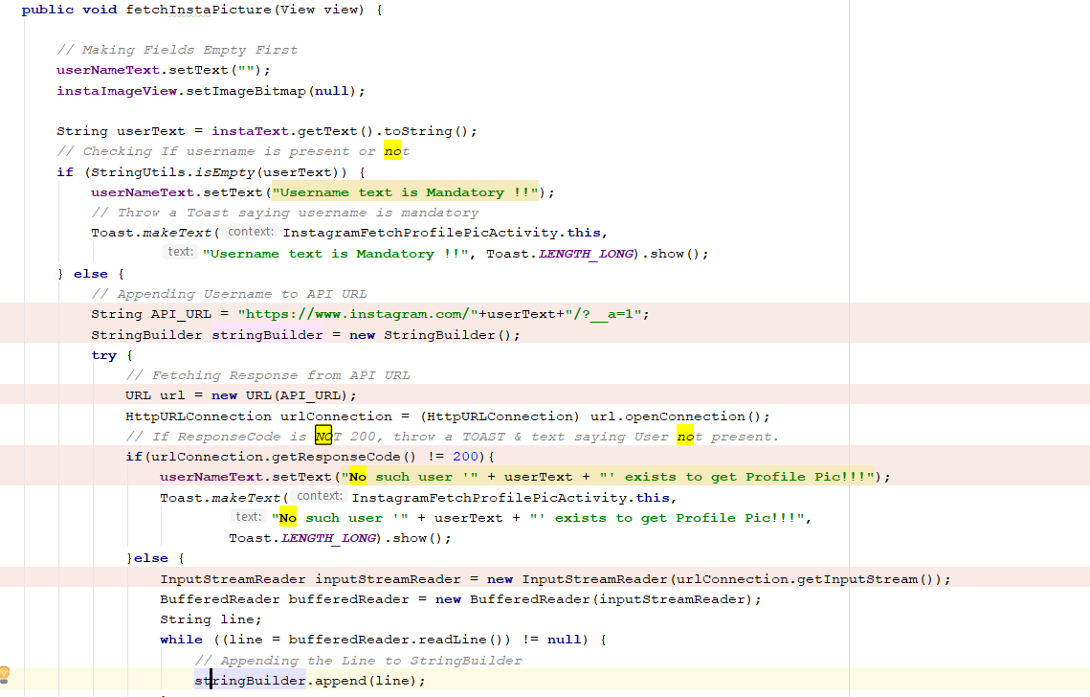

Following picture shows the UI of Instagram activity.

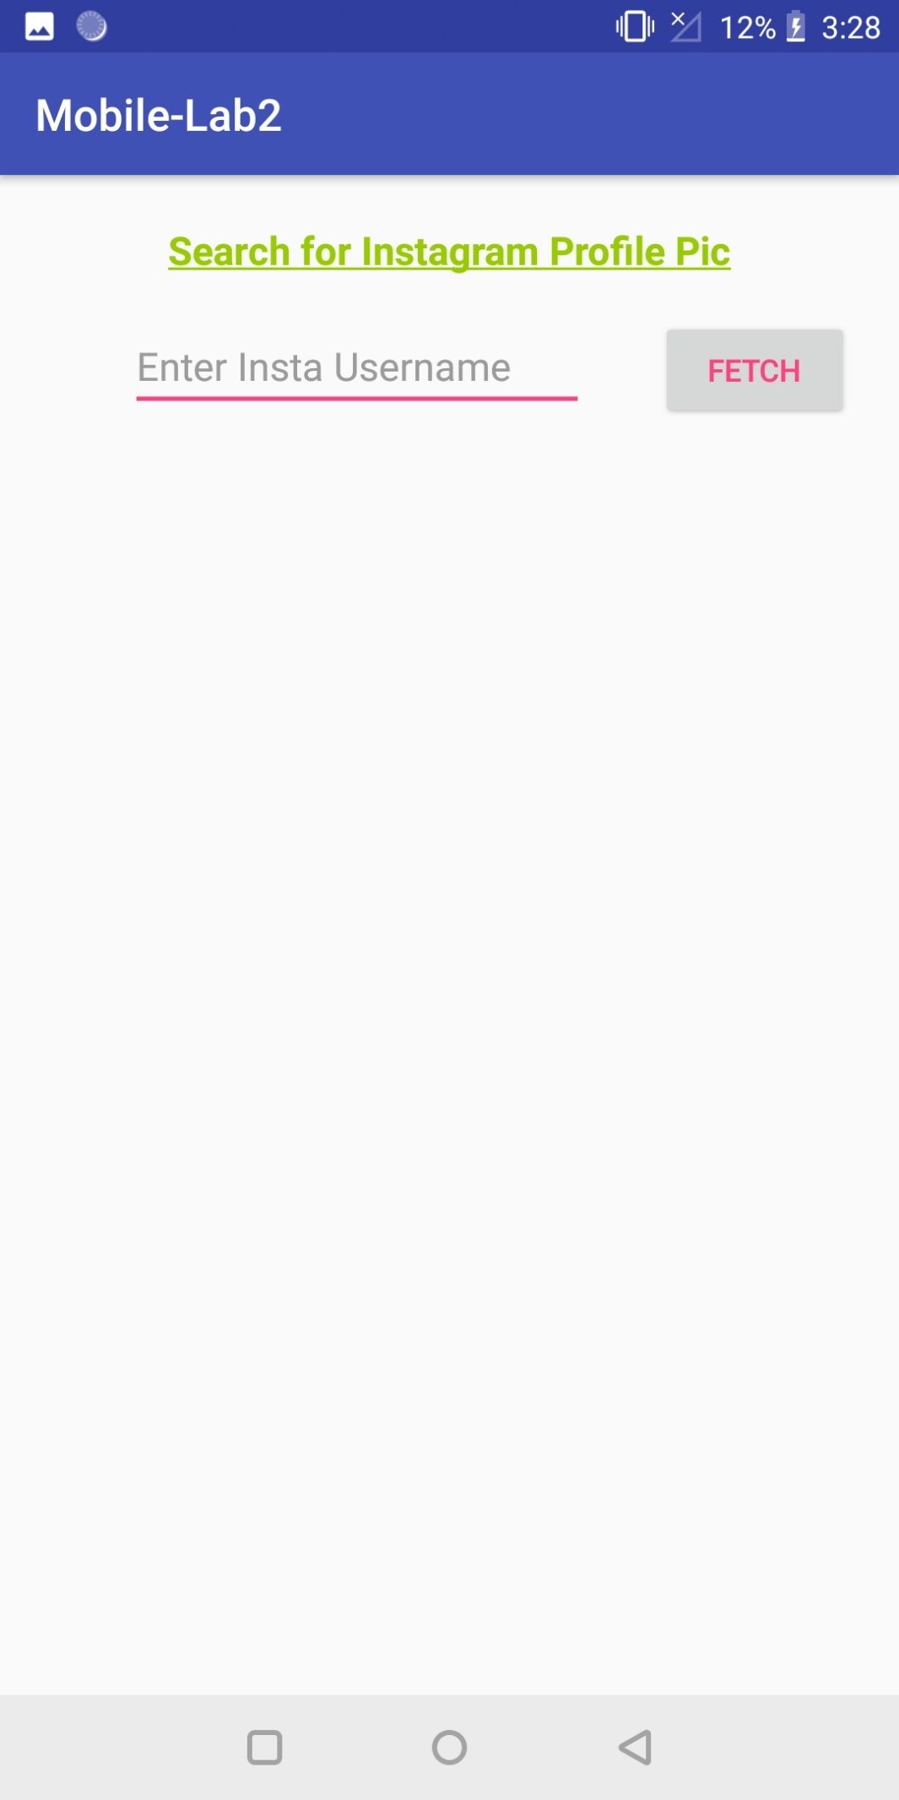

If the user name entered is incorrect, it shows as the following.

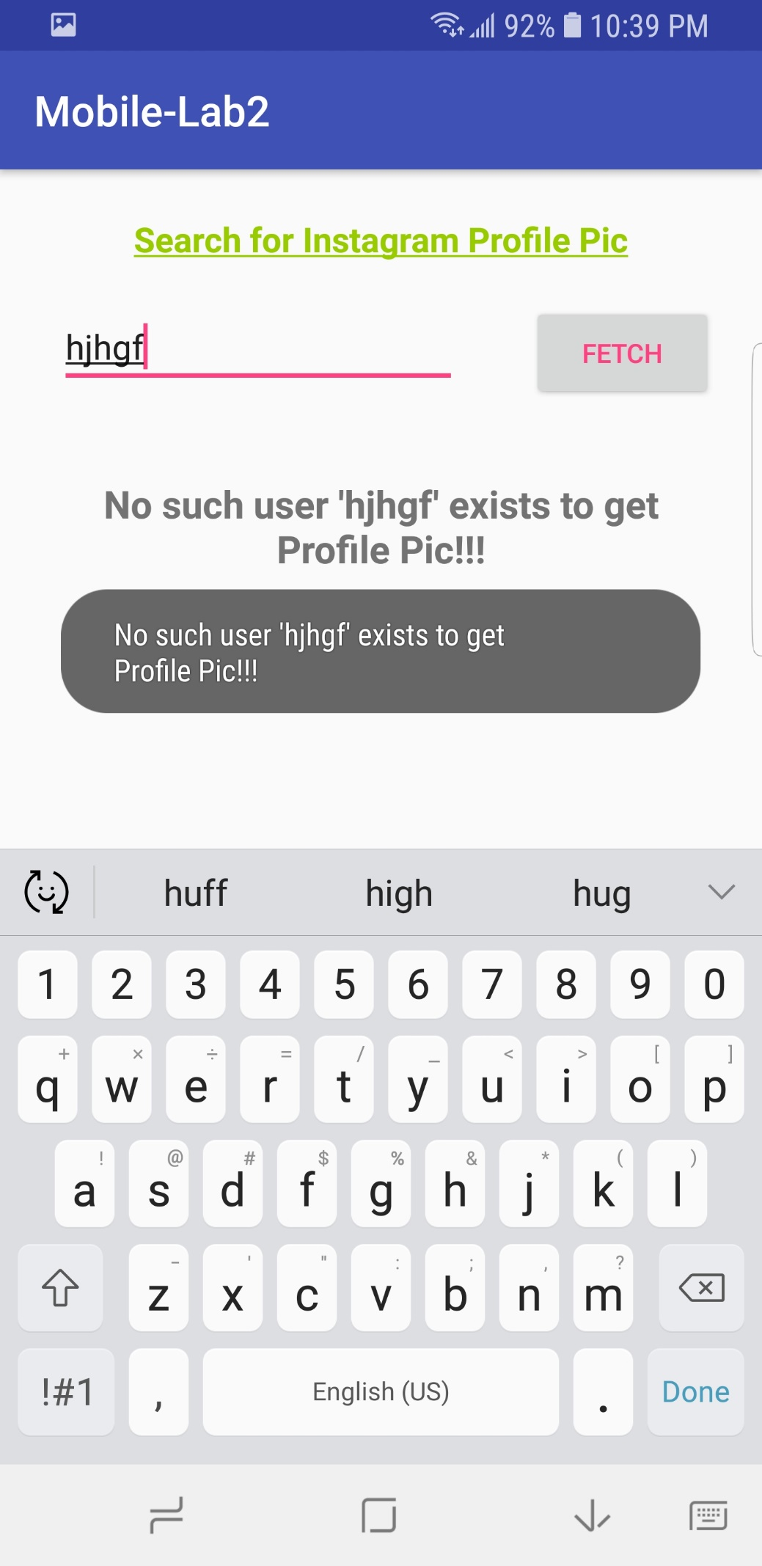

Output of the Instagram activity. It gives the follower count, profile pics and the follower count of the user.

